|  |
| --- |
| http://josetinoco.com |
| {{TBD}} |
| **Game documentation** |
| Version 1.0  All work (except images and sounds) copyright © 2016 by Joseph Tinoco.  All rights reserved. |
| **Joseph Tinoco** |
|  |

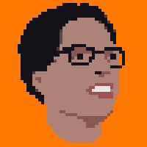

|  |
| --- |
| Feb 26th 2016 |

Contents

I. Game Overview 4

II. Game Play Mechanics 4

III. Interface Sketch 4

IV. Menu and Screen Descriptions 5

V. Scoring 6

VI. Sound Index 7

VII. Art / Multimedia Index 7

VIII. Design Notes 8

**Version History**

V0.1.0 – Initial document skeleton. Sep 17, 2016

# Game description

(Detailed).

# Controls

* The player ship can be moved around the screen with the WASD keys.
* The SPACE key shoots a laser.

# Interface Sketch

The wireframe below describes the game.

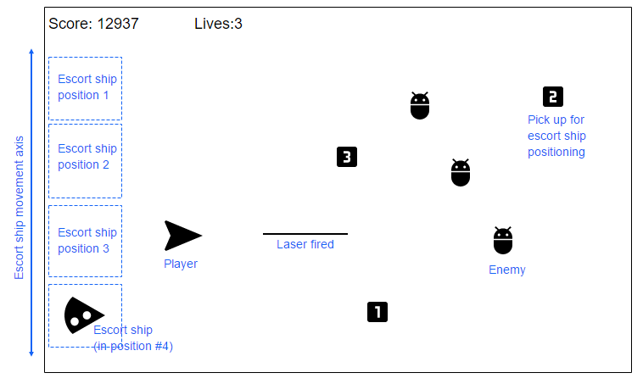

The player ship has free movement throughout the screen. The escort ship stays in one of the four designated positions. When the player picks up one of the positioning pick ups, the escort ship moves to the corresponding position.

# Screen Descriptions

The game presents an initial screen when first loaded, shown below. A click/tap on the “Play” game starts the game.

After playing, if the player quits the game, the “thank you” screen (below) is shown.

# Characters / Vehicles

Blabla

# Enemies

Blabla

# Scoring

The complete version of the payout table is shown below:

|  |  |  |  |
| --- | --- | --- | --- |
|  | Betting 1 credit | Betting 2 credits | Betting 3 credits |
| One coin (any position) | 2 | 4 | 6 |
| Two coins (any position) | 5 | 10 | 15 |
| Three coins | 10 | 20 | 30 |
| Three mushrooms | 15 | 30 | 45 |
| Three fruits | 20 | 40 | 60 |
| Three Yoshis | 50 | 100 | 200 |
| Three Marios | 100 | 200 | 300 |
| Three Stars | 500 | 1000 | 1500 |

The three star, 3 credits bet result (1500 credits) is the game’s **jackpot**. The game plays a special music when the player scores a jackpot.

# Sound Index

|  |  |  |
| --- | --- | --- |
| Asset name | Description | File name |
| StartSound | The initial sound played at the startup screen. | Start.wav |
| SpinningSound | The sound the reels make when they spin | Spinning.wav |
| StoppingSound | The sound a reel makes when it stops spinning | Stopping.wav |
| BetButtonSound | Played after the user clicks one of the bet buttons. | Betbutton.wav |
| JackpotSound | A special music played when the user gets a jackpot. | Jackpot.wav |
| WinSound | Played when the user wins anything less than 20 credits. | Win.wav |
| BigWinSound | Played when the user wins anything more than 20 credits, but less than the jackpot. | Bigwin.wav |
| LoseSound | Played when the user does not win anything in a wager. | Lose.wav |
| GoodbyeSound | Played when the user clicks “quit”. | Goodbye.wav |

# Art / Multimedia Index

The graphic elements used to build the slot machine are shown below.

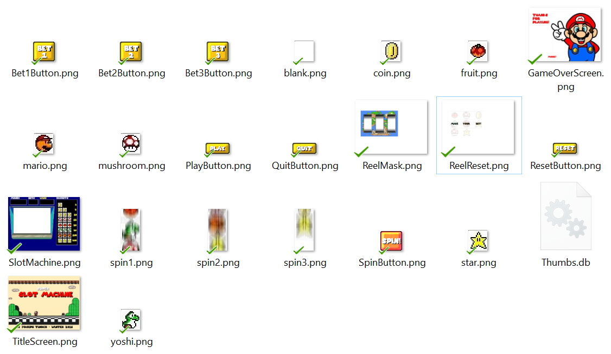

Notes about the image assets:

* “Spin1”, “Spin2” and “Spin3” are the frames of the spin turning animation.
* The slot machine is built on screen in the following order:
  1. **SlotMachine.png** (the base)
  2. **ReelReset.png** (the initial status of the reels when the player starts the game. It only displays a “make your bet” message).
  3. **Nine result images** shown in three lines on the machine “screen”, or frames of the reel spin animation.
  4. **ReelMask.png**, covering the reels to give it a “round” effect and partially cover the non-betting lines.
  5. Finally, the **labels** for player money, wins and bets are updated.